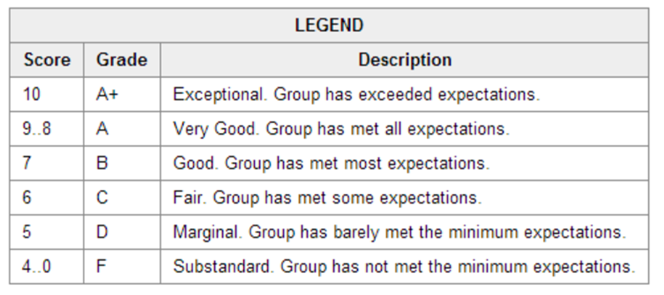Deliverable 4 Video Evaluation

Due:

Students:

|  |  |  |  |
| --- | --- | --- | --- |
| **Sections** | **Weight** | **Score** | **Weighted**  **Score** |
| Introduction – self , group, topic | 1 |  |  |
| Flow of presentation – continuity, transfer across group members, smooth, no dead air, video/slide progress in synch with transcript/notes | 2 |  |  |
| Engagement and storytelling – has a beginning, middle and end, overall value add is emphasized, sells the system to the client | 3 |  |  |
| Professionalism of presenters – tone, speech, attitude, behaviour, interest | 1 |  |  |
| Equal participation of each group member | 1 |  |  |
| Quality of presentation or video – professional production, one seamless final product, cohesion between group members and transitions | 2 |  |  |
| Appropriateness of software solution to business processes – relevant, complete, representative of case study, of benefit | 2 |  |  |
| Presentation within the timeframe, no overtime | 1 |  |  |
| Clear direction given at the end (recommendation) to the client | 1 |  |  |
| Subtitles or transcript/notes submitted as well as video file/slides | 1 |  |  |
| **Total** | 150 |  |  |